Twin Lakes Wetland Report
5/13/22
Gay Austin

The Colorado Native Plant Society is deeply committed to preserving fens and wetlands in Colorado. In Colorado, wetlands encompass 1.5% of the total land mass, and fens just 0.3% of mountain wetlands (Chimner and Cooper 2003). It has come to our attention that wetlands and potentially a fen are being hydrologically modified and dewatered just north of Twin Lakes in the area of Bartlett Gulch. This is potentially a Clean Water Act violation.

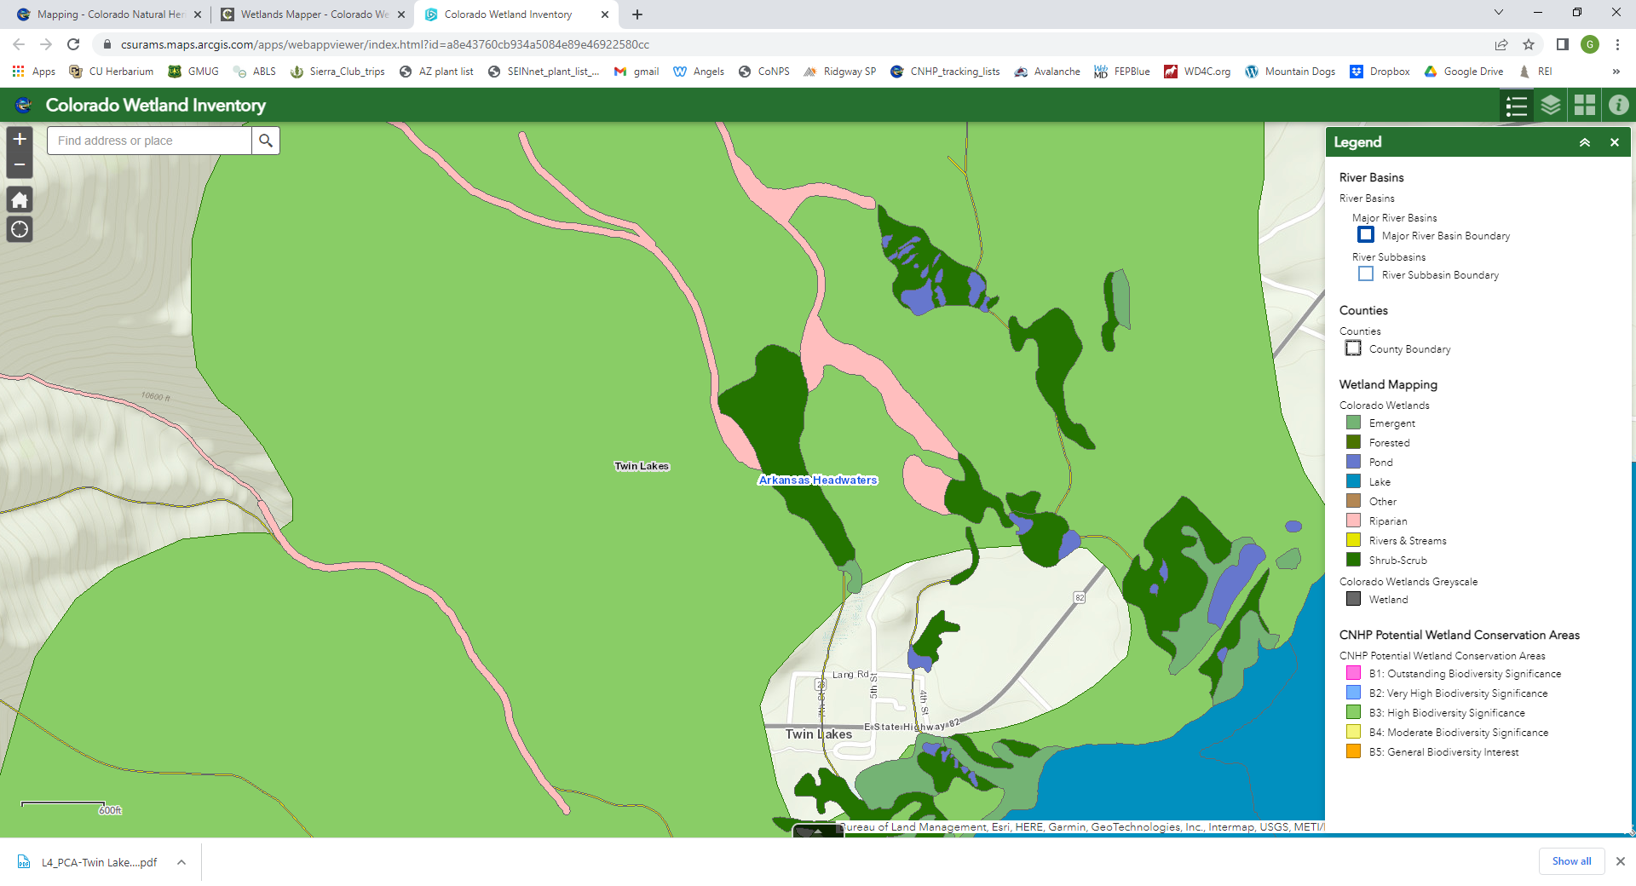
Colorado Wetlands Inventory Mapping Tool (accessed 5/21/2022) map of Twin Lakes area. The large green polygon shows a Potential Conservation Area of High Biodiversity Significance (CNHP 2019) because of the wetlands, small fens, and rare plants. See attached report. The area contains Forest Service and private lands. The pink color on the right side is the Bartlett Gulch riparian area and the dark green are wetlands.

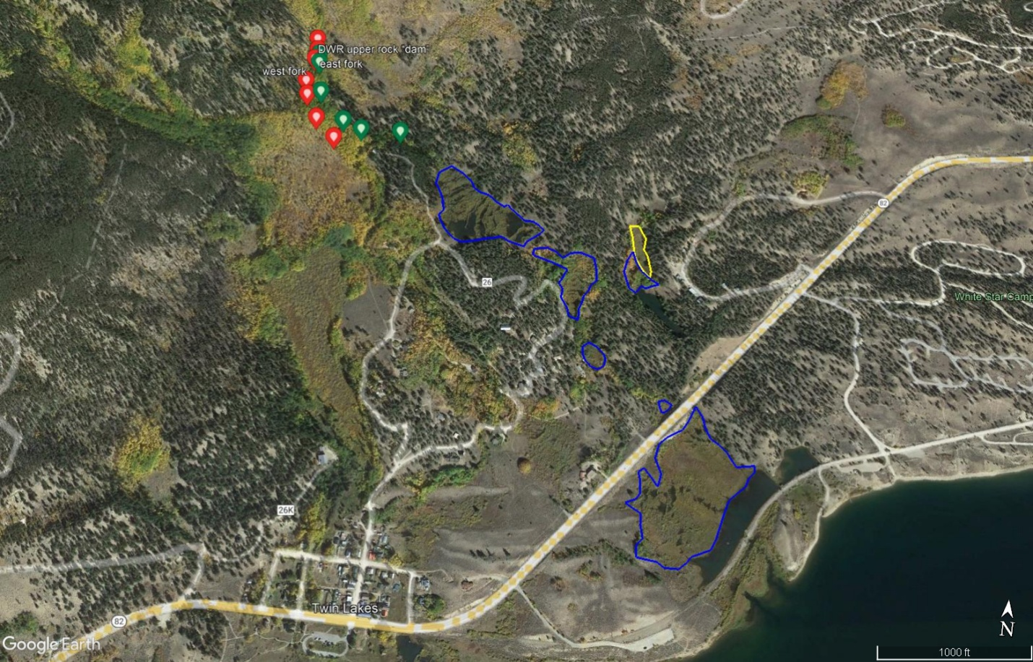

Overview map showing the town of Twin Lakes (bottom left), Twin Lakes (bottom right), a portion of Bartlett Gulch (red and green dots), the wetlands supported by the east fork of Bartlett Gulch (blue lines), and a fen (yellow).

At the bottom of this report is the attached National Wetland Inventory (NWI 1979) map showing red arrows pointing to the wetlands that are normally supported by perennial water flow in the east fork of Bartlett Gulch. The Mount Elbert topographic quadrangle map (2013) clearly shows a perennial stream along the east fork. Field surveys by Gay Austin verified that this water has been diverted to the west fork of Bartlett Gulch by the state Division of Water Resources (see field survey map below). Green dots represent points with photos along the dewatered east fork. Blue lines show the wetlands along this stretch. Red dots show the west fork where all of the Bartlett Gulch water is currently flowing. A fen is outlined in yellow. Since the DWR dams were put in place, beavers have moved down into the fen where there is still minimal groundwater flow. Impacts to fens that are drained are that oxygen begins to enter into the peat and the peat begins to decompose. Fens must continue accumulating peat in order to function as fens (Austin & Cooper 2015).

Acres of wetlands in the east fork area have been supporting beavers, migratory birds, elk, deer, bears, other wildlife species, and wetland plants for decades. Although there are multiple channels in Bartlett Gulch due to past landslides and large spring runoffs, the east channel has more evidence of sustained perennial flows. There are large wetlands with wetland plant communities such as beaked sedge (Carex utriculata), more willow growth than the west fork, beaver dams and ponds with current beaver activity. Beavers generally build dams along streams with perennial flows, not ephemeral or intermittent drainages.

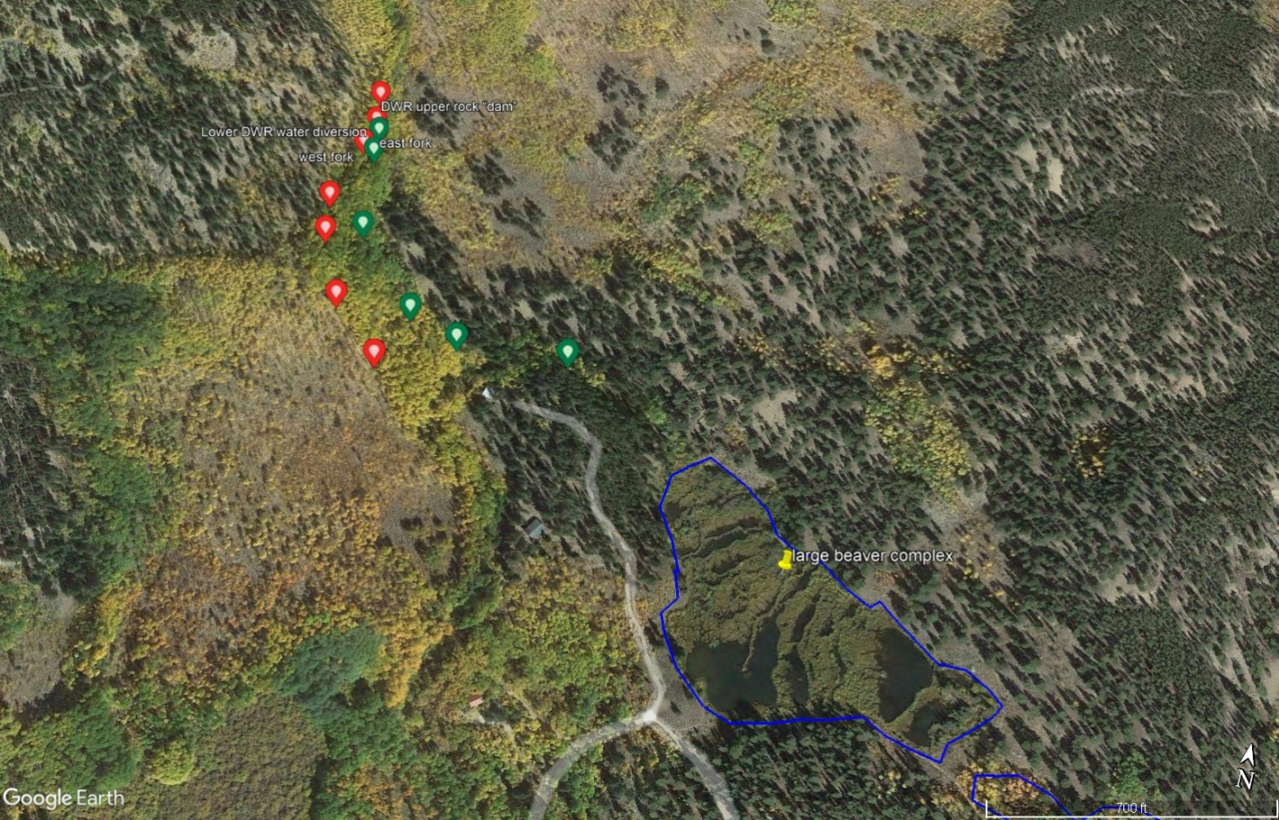

Closeup of middle section of Bartlett Gulch showing field survey points on the west fork (red dots), east fork (green dots), and a large beaver complex supported by perennial water flow from the east fork.

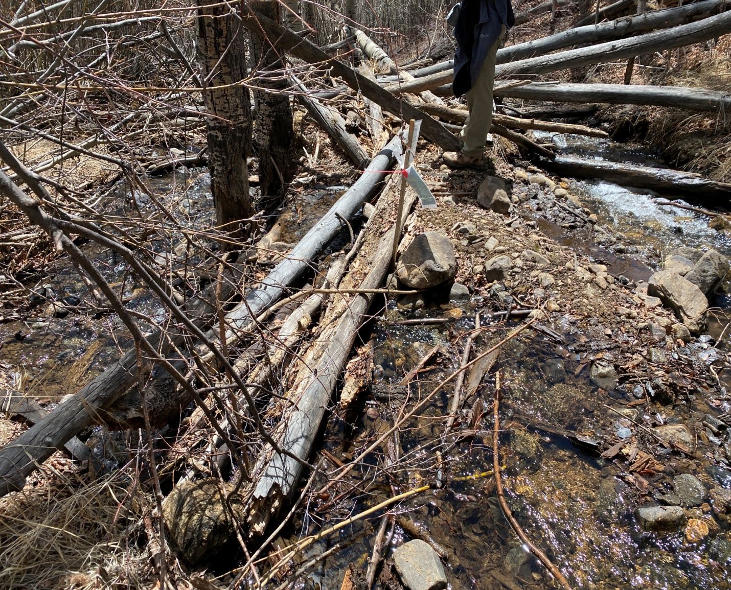

Looking south with east fork on left and west fork on right. Upper DWR partial diversion of Bartlett Gulch showing use of old beaver dam to partially move the flow of Bartlett Gulch to the west fork.

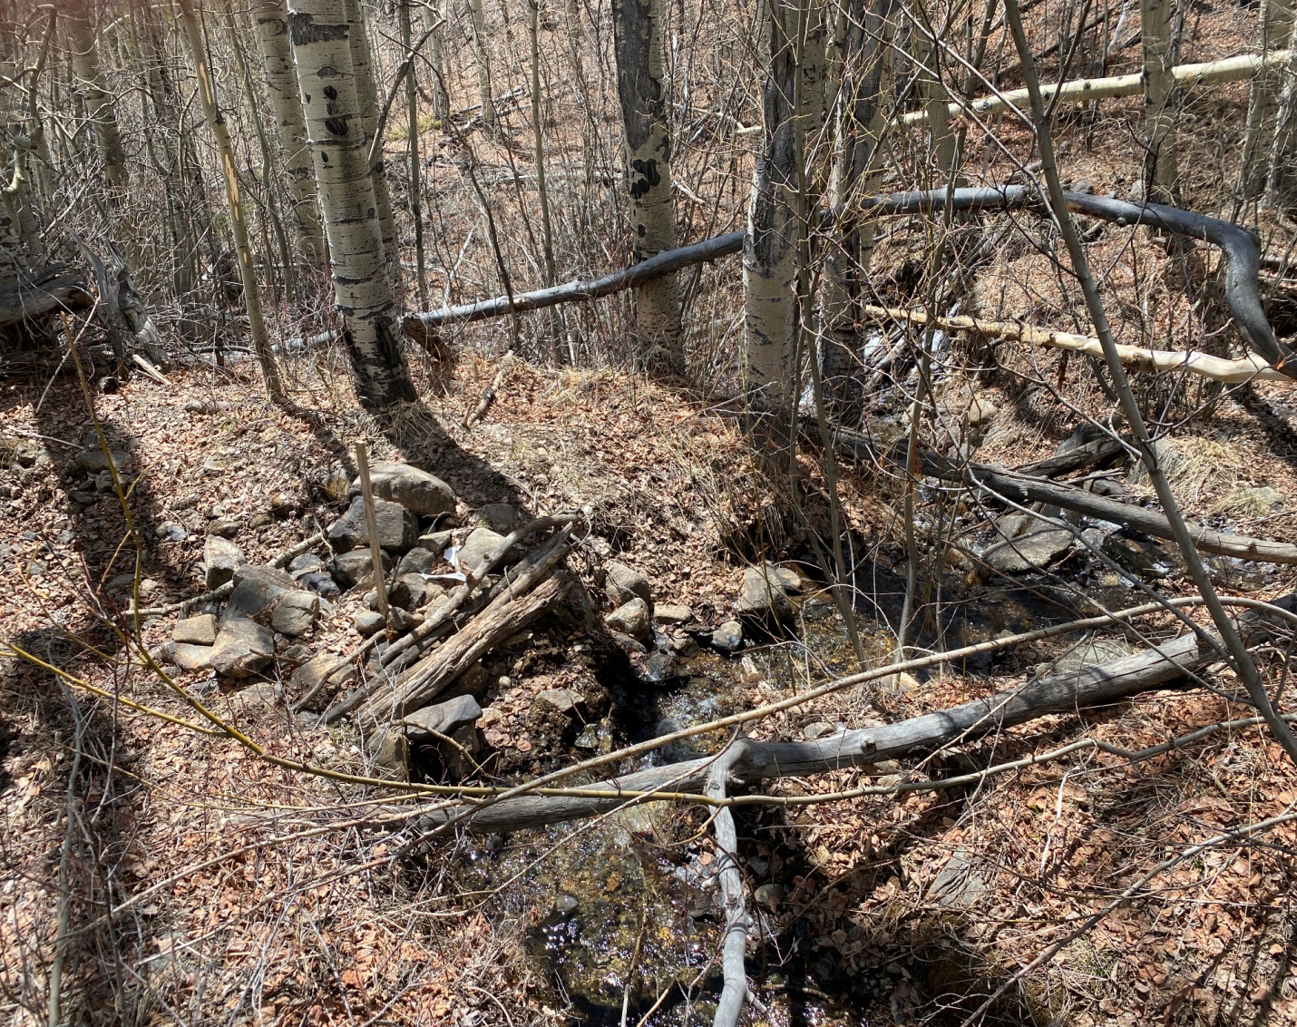

Looking south just below 1st dam at DWR 2nd dam (black arrow), plugging the east fork on the left. West fork is on the right where all the water from Bartlett Gulch is now flowing.

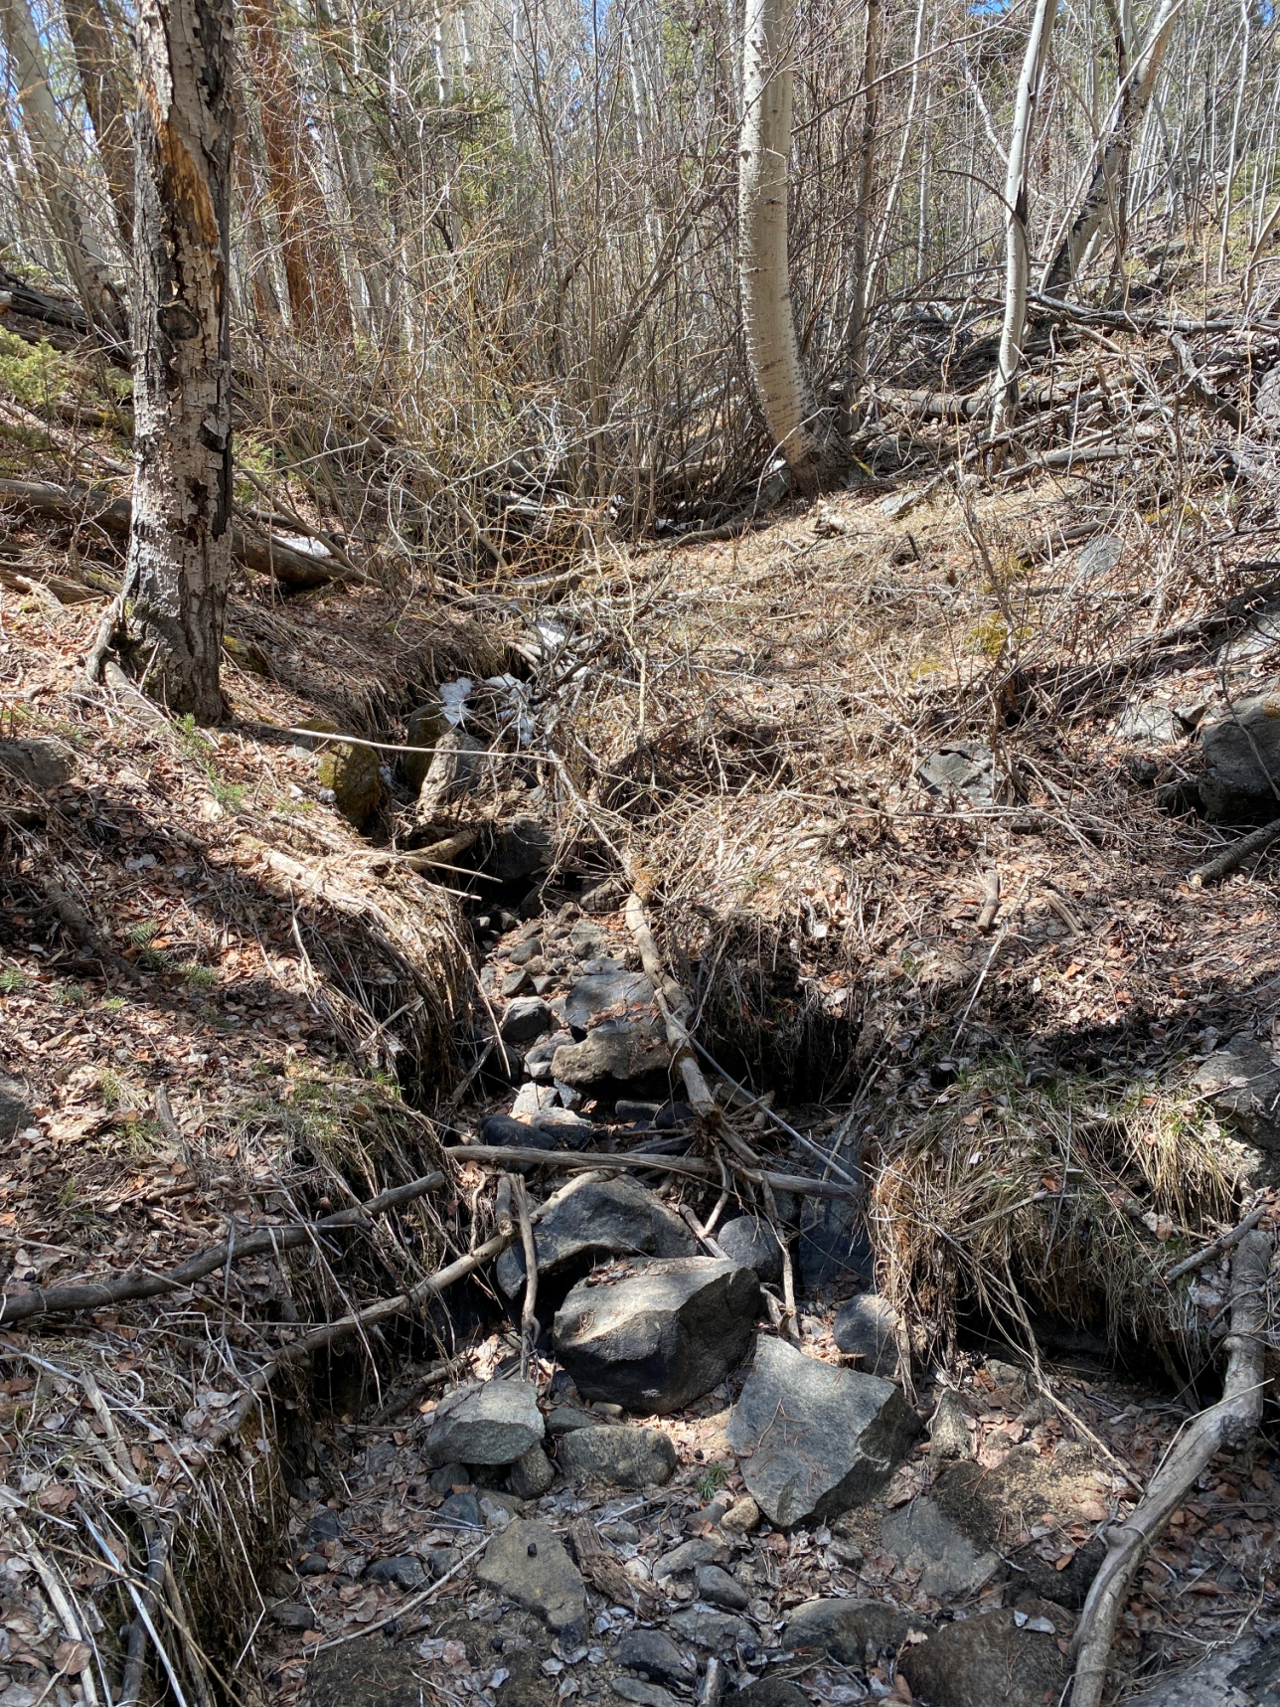

East fork of Bartlett Gulch showing dewatered channel.

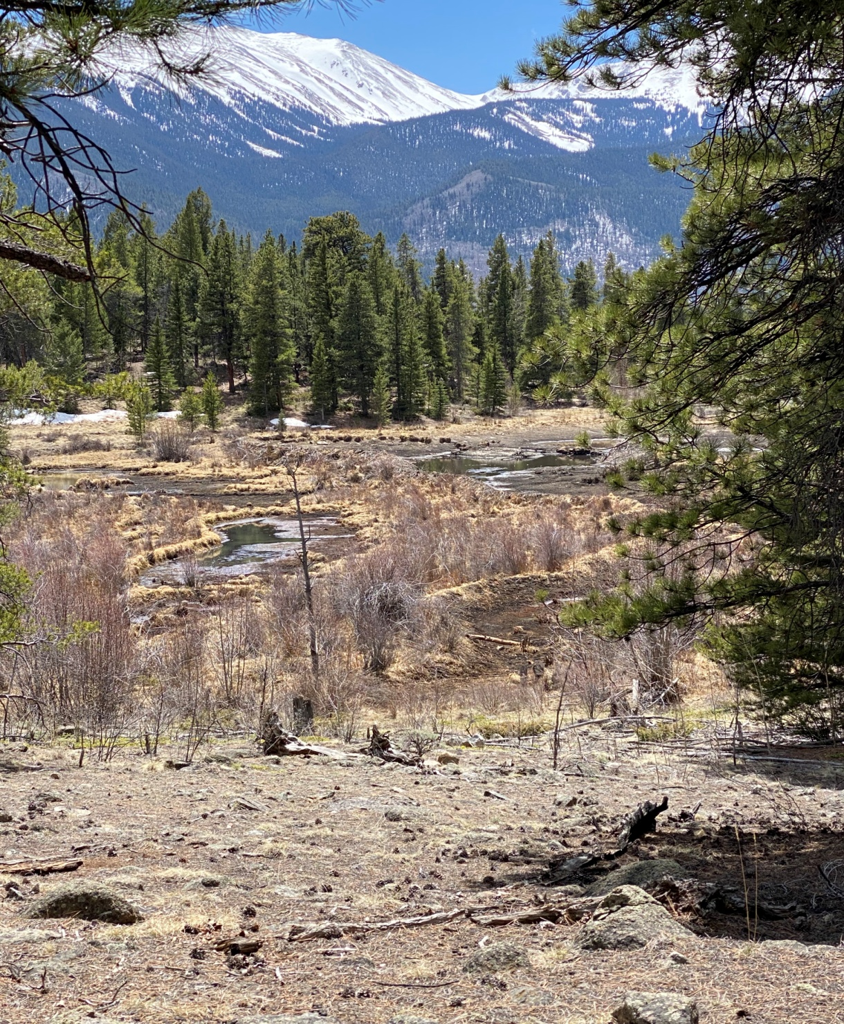

Looking south at large beaver complex just below dewatered east fork of Bartlett Gulch.

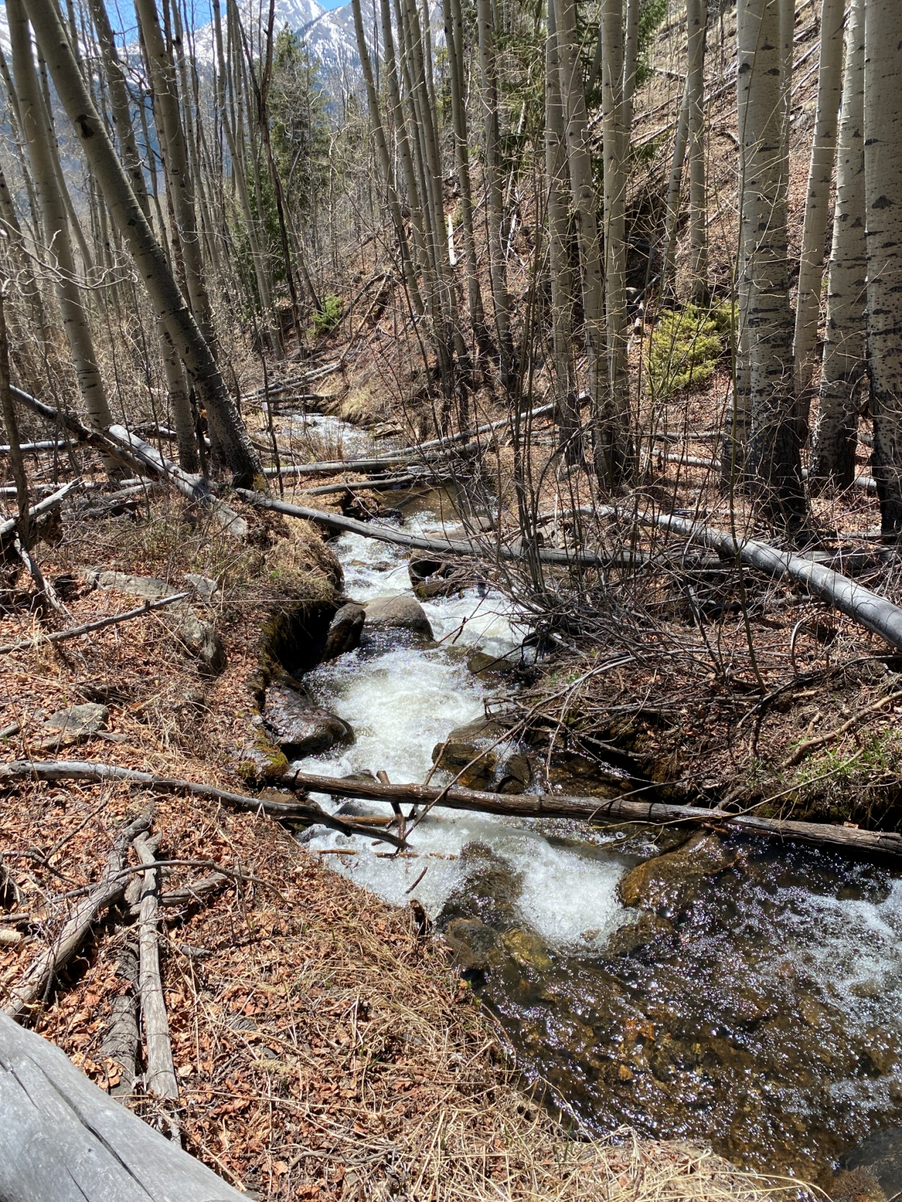

West fork of Bartlett Gulch showing water flow.

Gay Austin is a retired botanist and ecologist. She worked 22 years with the Gunnison Ranger District USDA Forest Service and 7 1/2 years with the Gunnison Field Office USDI Bureau of Land Management. She has a master’s degree in Botany-Ecology from Prescott College. Her thesis title was Fens of Grand Mesa, Colorado: Characterization, Impacts from Human Activities, and Restoration.

